Context Level DFD:-

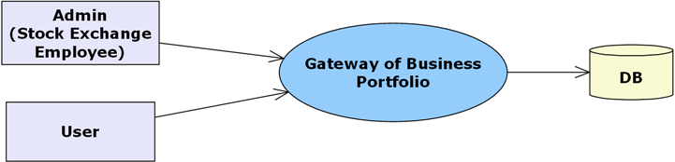

Level 0 DFD for Admin:

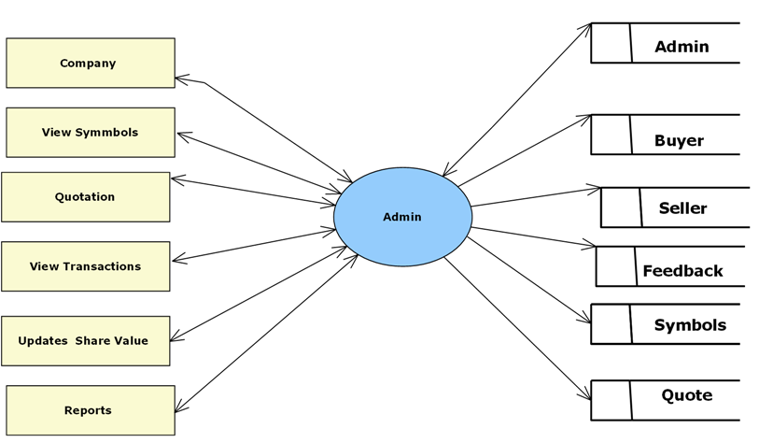

0 Level DFD for View User :-

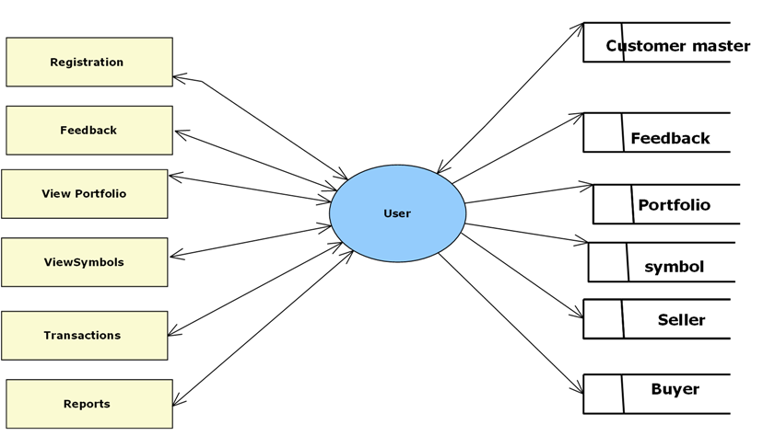
1 Level DFD for Company:-

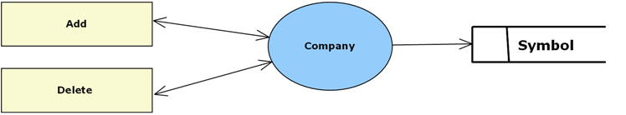

1 Level DFD for Quotation:-

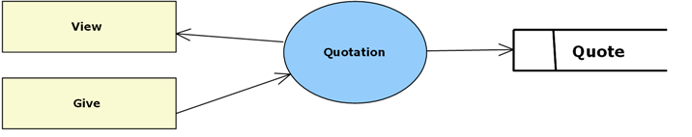

1 Level DFD for View Transaction:-

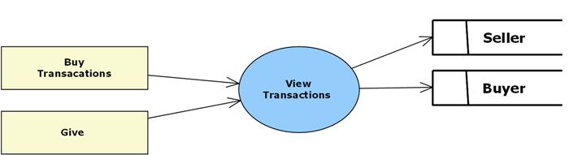
1 Level DFD for View Reports:-

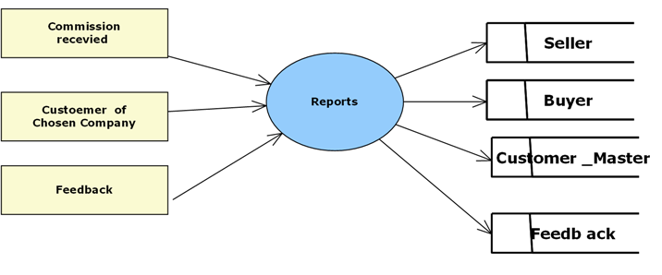

Level 1 DFD forTransactions :-
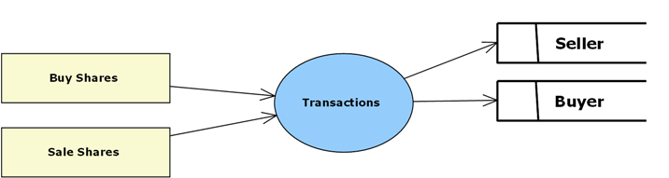

Level 1 DFD for User Reports:-

